# CS 255 System Design Document Template

Buxton McCaslin

## UML Diagrams

### UML Use Case Diagram

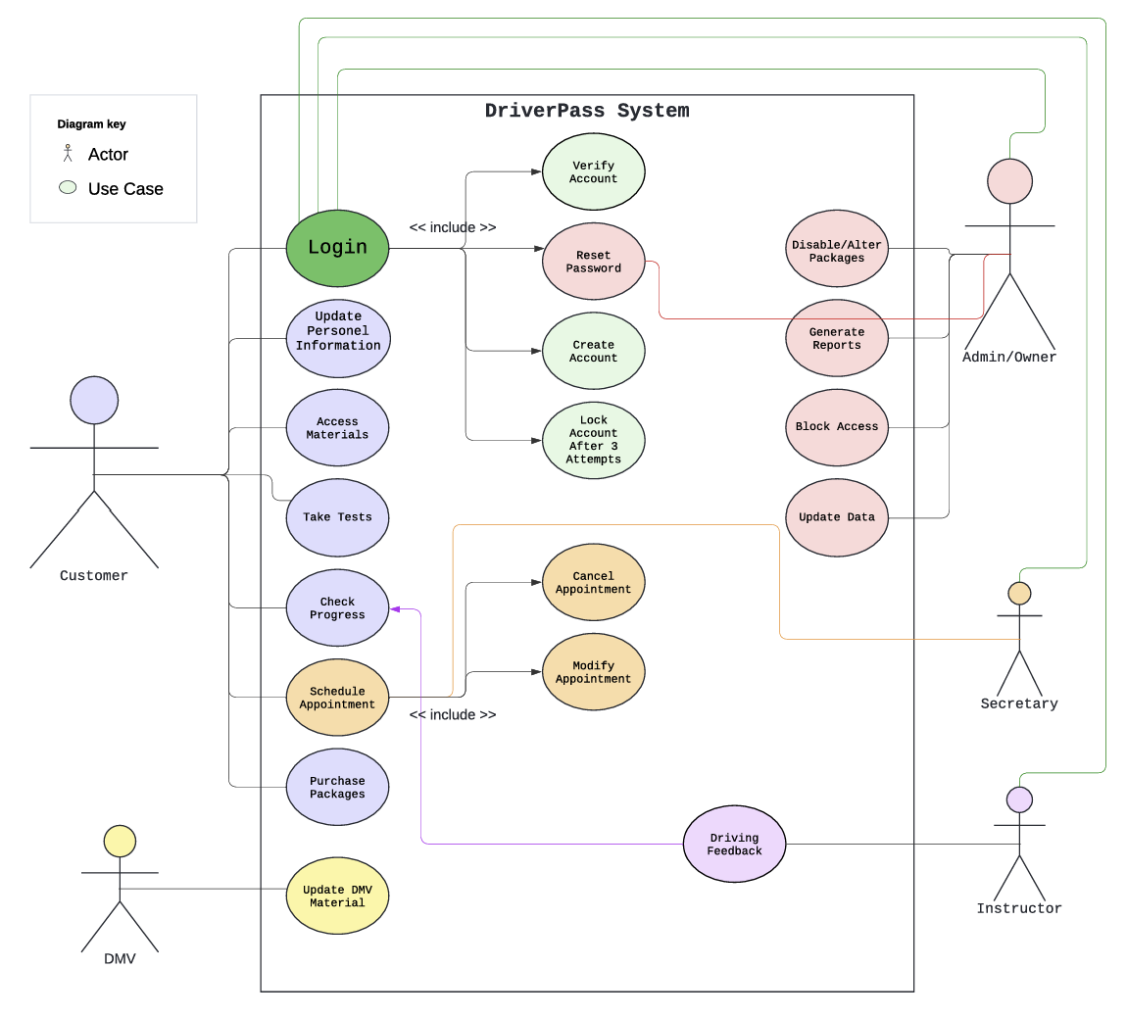

### UML Activity Diagrams

### 

### UML Sequence Diagram

### UML Class Diagram

## Technical Requirements

Hardware Requirements:

* At least one dedicated server
* Power sources
* Computer interface or mobile device
* Internet

Software Requirements:

* Web browser
* Operating system
* Security Software
* Server operating system (windows)
* SQL server (recommended)
* DriverPass software

Considerations:

* Server location
* Cloud provider
* Vehicles
* Insurance, registration
* Stable power for the office
* Adequate equipment for the office
* Payment process company contracts
* Ensure website accessibility
* Network admin tools